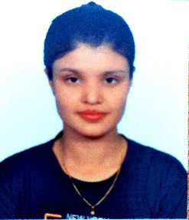 **RESUME**

**AAYUSHI SIRASAO**

+91 70674-48908

[8109623264a@gamil.com](mailto:8109623264a@gamil.com)

**OBJECTIVES**

To work with an ‘Organization’ where I can develop my skills, knowledge and work on myself.

**EDUCATION / QUALIFICATION**

* Passed out 10th from C.B.S.E
* Passed out 12th from C.B.S.E
* Pursuing in B.B.A IIIrd year {Final}

**SKILLS**

* MS Word
* Power Point
* Can speak Hindi, English and Marathi

**WORK EXPERIENCE**

* Fresher

**PERSONAL DETAILS**

Father’s Name : Mr. Deepak Srasao

Mother’s Name : Mrs. Dipti Sirasao

Permanent add : 292-A H.B.C Nariyal Kheda Bhopal (M.P)

DOB : 15-JUNE-2001

Marital Status : Single